Can bike rental demand in Seoul be accurately classified into demand categories using weather, temporal and calendar related features?
Which classification models provide the best predictive performance for bike demand classification, and how does deep learning compare to classical, statistical and machine learning approaches?

Which weather and temporal variables are most influential in determining high versus low bike rental demand?

Christo Tomy
MAST6100 – Machine learning and deep learning

Abstract
Although bike sharing programs are essential for encouraging sustainable urban mobility, their effective operation greatly depends on precise demand forecasting. This project investigates whether hourly bike rental demand in Seoul can be effectively classified into multiple demand levels using weather related, temporal, and calendar-based predictors. Using the Seoul bike sharing demand dataset, the continuous rental count variable is transformed into a multiclass target, representing low, medium, and high demand periods, enabling a more operationally meaningful classification task.
Several classification models are developed and compared, including a multinomial Generalised Linear Model (GLM), classical machine and deep learning models. Appropriate multiclass metrics, such as overall accuracy, confusion matrices, and class-wise performance measures, are used to assess model performance. In addition to predictive performance, the project examines the trade-off between model interpretability and complexity, with particular attention given to the explanatory insights provided by simpler models versus the accuracy gains of more complex approaches.
The findings show that demand levels are significantly influenced by weather and temporal factors, and that more flexible models typically achieve better predictive performance at the expense of less interpretability. These results shed light on the advantages and disadvantages of various modelling approaches and demonstrate the usefulness of multiclass classification for assisting decision making in bike sharing operations

Introduction
Bike sharing systems have become an increasingly important component of sustainable urban transportation, offering an environmentally friendly alternative to private vehicle use while reducing congestion in densely populated cities. Understanding and predicting user demand is crucial to the effective operation of such systems, due to periods of excess or insufficient supply can result in subpar service and higher operating expenses. For transport operators and city planners, accurate demand modelling is therefore a major challenge.
Recent years have seen a widespread application of machine learning techniques to transportation demand prediction issues, with studies emphasising the impact of calendar effects, temporal patterns, and weather on bike sharing usage. While many existing studies focus on regression-based approaches to predict exact rental counts, framing the problem as a classification task can offer greater practical value. Categorising demand into discrete levels allows operators to implement targeted operational strategies, such as reallocating bikes or adjusting staffing levels during high demand periods.
In this project, a real-world dataset with weather, temporal, and calendar-related variables is used to classify the demand for hourly bike rentals in Seoul. The rental count is converted into a multiclass target that represents low, medium, and high demand periods rather than forecasting a continuous outcome. This method offers a framework for demand analysis that is easier to understand and more focused on making decisions.
To address this problem, three classification models of increasing complexity are developed and compared. These are a multinomial Generalised Linear Model (GLM), a random forest classifier, and a deep neural network. This selection enables a structured comparison between classical statistical methods, ensemble-based machine learning techniques, and modern deep learning approaches. Model performance is evaluated using appropriate multiclass classification metrics, while additional emphasis is placed on interpretability and the trade-off between model complexity and predictive accuracy.

Data and Methodology
  - Data description
The dataset used in this project is the Seoul bike sharing demand dataset, which contains hourly records of bike rental activity in Seoul. Each observation corresponds to a single hour and includes information on the number of bikes rented as well as a range of explanatory variables capturing environmental and temporal conditions.
The dataset consists of over 8,000 observations and includes more than ten predictor variables, satisfying the assessment requirements for dataset size and complexity. The explanatory variables can be broadly grouped into three categories: weather related variables (such as temperature, humidity, wind speed, rainfall, and snowfall), temporal variables (including hour of the day, day of the week, and season), and calendar-based indicators (such as holidays and functioning days). These characteristics are frequently mentioned in research as significant factors influencing the demand for bike sharing.
The original target variable, Rented Bike Count, is a continuous measure representing the total number of bikes rented in each hour. As the focus of this project is classification rather than regression, this variable is transformed into a categorical outcome, as described in the following section.
  - Target variable construction
To formulate a multiclass classification problem, the continuous bike rental count is discretised into three demand levels: low, medium, and high demand. This transformation is achieved using quantile-based thresholds, where the lower third of observations corresponds to low demand, the middle third to medium demand, and the upper third to high demand.
This approach offers several advantages. First, it avoids the use of arbitrary thresholds by relying on the empirical distribution of the data. Second, it results in relatively balanced class sizes, which is beneficial for model training and evaluation. Finally, categorising demand into multiple levels provides a more operationally meaningful outcome, as different demand systems may require distinct management strategies.
  - Modelling approach
This study uses three classification models, each of which represents a higher degree of model flexibility and complexity.
The first model is a multinomial Generalised Linear Model (GLM), which serves as a baseline statistical classifier. This model yields interpretable parameter estimates that quantify the impact of individual variables and assumes a linear relationship between the predictors and the log odds of each demand category. The GLM offers transparency and allows for direct insight into how weather and temporal factors influence demand levels.
The second model is a random forest classifier, a classical ensemble-based machine learning method that combines multiple decision trees through bootstrap aggregation. As they can capture nonlinear relationships and interactions between predictors while remaining robust to noise and multicollinearity, random forests are a good fit for this problem. Random forests offer measures of variable importance in addition to predictive performance, allowing for additional understanding of the relative impact of various features.
The third model is a deep neural network, representing a modern deep learning approach to classification. The neural network can learn intricate nonlinear decision boundaries because it is built as a multi-layer perceptron. While such models often achieve high predictive accuracy, they are less interpretable than traditional statistical methods. Including a deep learning model therefore enables an explicit comparison between accuracy gains and interpretability loss.
  - Model training and evaluation
The dataset is divided into training and testing subsets to evaluate out of sample performance. When necessary, appropriate preprocessing techniques are used, especially for the neural network model, such as feature scaling and categorical variable encoding. All models are trained using the same data split to ensure a fair comparison.
Multiclass classification metrics, such as confusion matrices and overall accuracy, are used to evaluate model performance, with special attention paid to class specific performance. This evaluation framework allows for a comprehensive comparison of the models’ predictive capabilities while highlighting differences in how well each model identifies varying demand levels.

Exploratory Data Analysis
  - Demand class distribution and data quality
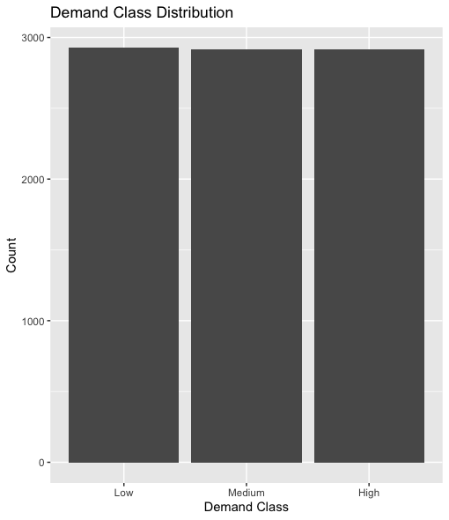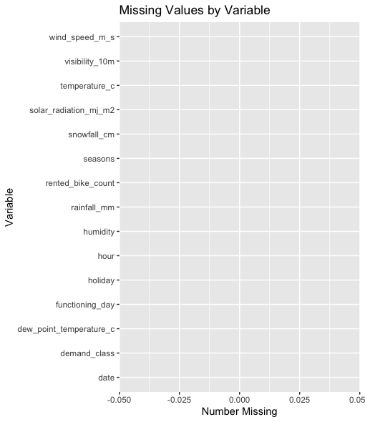
The three demand classes (low, medium, and high) are comparatively balanced, according to the target variable's distribution. This outcome is expected given the use of quantile-based thresholds when constructing the multiclass target variable. For classification modelling, balanced class sizes are beneficial because they lower the possibility of biased predictions in favour of a dominant class and enable more insightful comparisons of model performance across demand levels.
Examining the missing values shows that no variable is missing, indicating that the dataset is complete. This ensures that the analysis is not driven by imputation choices and supports the reliability of the subsequent modelling results.
  - Temporal patterns in bike demand
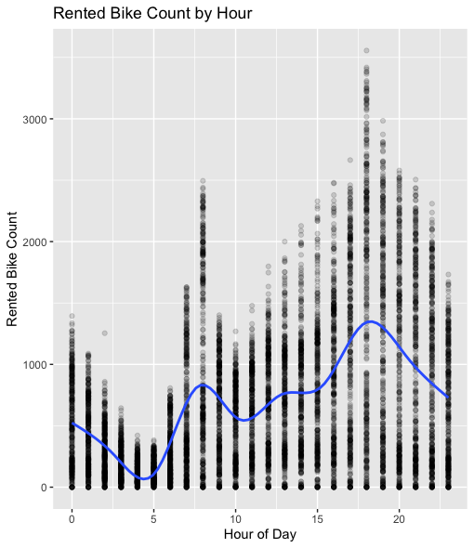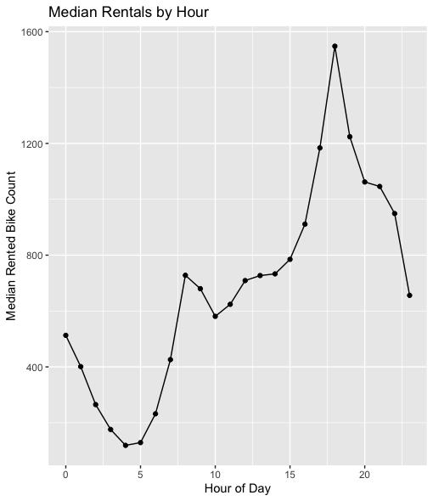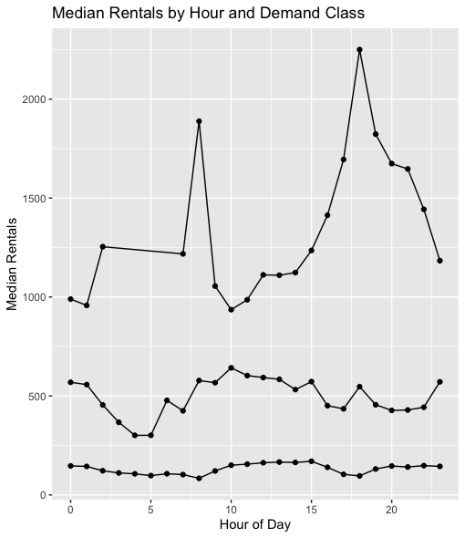
Exploratory analysis reveals a strong temporal structure in bike rental demand across the day. Rental activity tends to increase during morning and evening hours, corresponding to typical commuting periods, while demand is lower during late night and early morning hours. This pattern supports the inclusion of hourly variables in the classification models and indicates that time of day is a significant predictor of demand.
When examining demand levels by hour, high demand periods are concentrated around peak commuting times, whereas low demand observations are more prevalent outside these intervals. This distinct division suggests that temporal characteristics are likely to be crucial in differentiating between demand classes.
  - Weather variables and demand levels
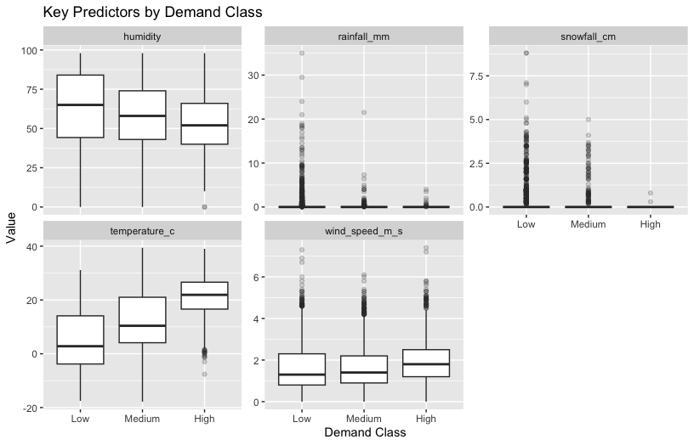
Boxplots of key weather-related variables demonstrate clear differences in their distributions across demand classes. More favourable weather conditions, such as higher temperatures and less rainfall and snowfall, are typically linked to higher demand levels. In contrast, low demand periods tend to coincide with adverse weather conditions, including colder temperatures and increased precipitation.
These trends suggest that weather variables are useful predictors for classifying demand and will probably have a major impact on model performance, especially when it comes to differentiating between periods of high and low demand.
  - Correlation structure among predictors
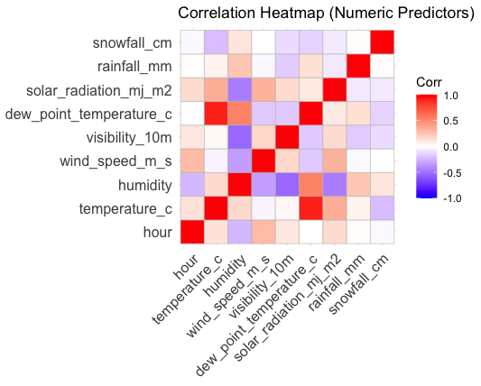
The correlation analysis of numeric predictors reveals moderate correlations between certain weather variables, such as temperature and humidity, while most predictors exhibit relatively low pairwise correlations. This implies that the dataset is appropriate for both statistical and machine learning techniques since multicollinearity is present but not severe.
The presence of correlated predictors further motivates the inclusion of ensemble-based and nonlinear models, such as random forests and neural networks, which are less sensitive to multicollinearity and can capture complex interactions between variables.

Results and findings
  - Multinomial Generalised Linear Model
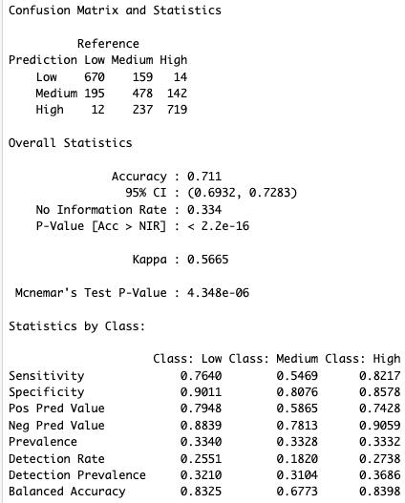
With an overall accuracy of 71.1%, the multinomial Generalised Linear Model established a strong foundation for demand classification. Performance varied across demand levels, with particularly strong sensitivity for high demand periods (82.2%) and low demand periods (76.4%), while medium demand periods proved more difficult to classify accurately. This reflects the linear nature of the GLM, which struggles to capture the more subtle boundary between medium and adjacent demand classes.
The GLM showed strong specificity across all classes despite these drawbacks, suggesting a low rate of false positive classifications. The model’s interpretability allows for direct insights into how weather and temporal predictors influence demand levels, making it valuable from an explanatory perspective even if predictive performance is moderate.
  - Random Forest model
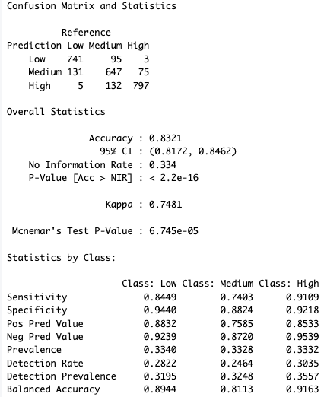
With an overall accuracy of 83.2% and a significant increase in Cohen's Kappa over the GLM, the random forest classifier demonstrated the best predictive performance. The model performed consistently well across all demand levels, particularly in identifying high demand periods, where sensitivity exceeded 91%.
The improved performance reflects the model’s ability to capture nonlinear relationships and interactions between predictors. Variable importance analysis indicates that temporal features, particularly hour of the day, are the most influential predictors, followed by key weather variables such as temperature and humidity. These results closely match the trends found in the exploratory data analysis.
  - Neural Network
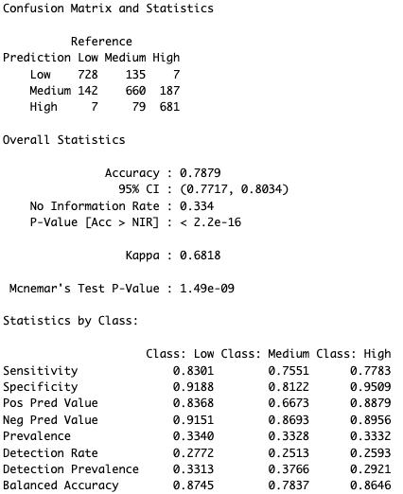
The neural network model achieved an overall accuracy of 78.8%, outperforming the GLM but falling short of the random forest. With strong sensitivity for low and medium demand periods and marginally lower performance for high demand observations, the model showed balanced performance across demand classes.
While the neural network can model complex nonlinear relationships, its performance suggests that, for this dataset, ensemble-based methods are more effective. Additionally, the neural network does not offer the same degree of transparent feature importance as the random forest and has less interpretability than the GLM.

Discussion
The purpose of this study was to compare the performance of statistical, machine learning, and deep learning models and determine whether hourly bike rental demand in Seoul could be efficiently divided into several demand levels using weather, temporal, and calendar-based predictors.
The results demonstrate that multiclass classification of bike demand is feasible, with all three models achieving accuracies substantially higher than the no-information rate. Among the approaches considered, the random forest classifier consistently outperformed both the multinomial GLM and the neural network, highlighting the importance of modelling nonlinear relationships and feature interactions in this context.
Although the neural network improved upon the GLM, it did not surpass the random forest in terms of predictive accuracy. This implies that classical ensemble methods may provide a better balance between model complexity and performance than deep learning techniques for structured tabular data of moderate dimensionality.
Crucially, the GLM is still useful for interpretability, offering distinct insights into the impact of important predictors like weather and time of day effects. This highlights a fundamental trade-off between interpretability and predictive power, with simpler models offering greater transparency and more complex models delivering improved accuracy.
From a practical perspective, the ability to accurately identify high demand periods is particularly valuable for bike sharing operators, as it enables proactive resource allocation and improved service reliability. The strong performance of the random forest in this regard suggests that such models could be effectively integrated into operational decision support systems.

Conclusion
Using weather, temporal, and calendar-based predictors, this project investigated the viability of dividing Seoul's demand for hourly bike rentals into several demand levels. By transforming a continuous demand variable into a multiclass outcome, the study framed the problem in a way that is both operationally meaningful and well suited to modern classification techniques.
Three models of increasing complexity were developed and evaluated: a multinomial Generalised Linear Model, a random forest classifier, and a neural network. The findings show that all three methods can forecast demand levels with performance significantly better than the baseline without any information. However, clear differences emerged in terms of predictive accuracy, robustness, and interpretability.
The random forest classifier consistently identified high, medium, and low demand periods with strong accuracy and balanced class-wise results, outperforming all other models. This highlights the importance of capturing nonlinear relationships and interactions between predictors when modelling bike sharing demand. The neural network also demonstrated improved performance relative to the GLM, but did not surpass the random forest, suggesting that for structured tabular data of moderate size, ensemble-based machine learning methods may offer a more effective balance between complexity and performance than deep learning approaches.
Overall, the study's results show that multiclass classification is a useful and instructive method for examining bike sharing demand. From a practical perspective, the ability to accurately identify high demand periods can support more efficient resource allocation and operational planning in urban bike sharing systems. To further improve predictive performance, future research could investigate the addition of more contextual variables, different class definitions, or temporal dependency structures.

Reference

UCI Machine Learning Repository (2019). Seoul Bike Sharing Demand Data Set. Available at: https://archive.ics.uci.edu/ (Accessed: [13/12/25]).

Appendix
  - Appendix A: R Code

The full R code used for data preprocessing, exploratory analysis, and model fitting is provided in the accompanying GitHub repository and included as a separate script file (Bikers_In_Seoul_Final.R).

  - Appendix B: Model Hyperparameters

This appendix summarises the key hyperparameters used for each classification model. When appropriate, default settings were kept, and model complexity was chosen to strike a balance between overfitting risk and predictive performance.

Multinomial GLM
- Link function: multinomial logit
- Reference class: Low demand
Random Forest
- Number of trees: 500
- Splitting Criterion: Gini Impurity
- Sampling: Bootstrap aggregation
Neural Network
- Architecture: Multi-layer perceptron
- Hidden layers: 2 (64 and 32 units)
- Activation functions: ReLU, Softmax
- Optimiser: Adam
- Loss function: Categorical cross-entropy
- Regularisation: Dropout (0.3)

  - Appendix C: Additional Figures
Supplementary figures and tables are provided to support the analysis presented in the main body of the report.

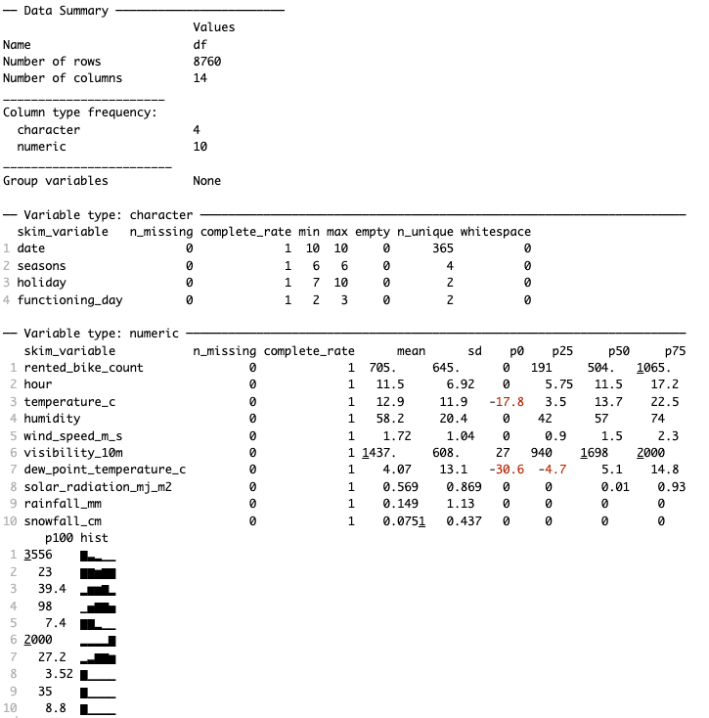
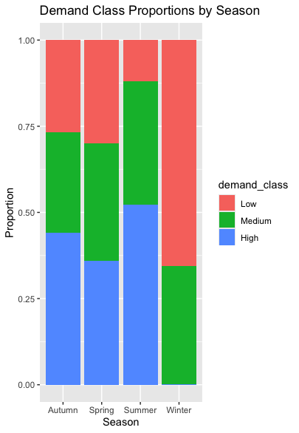

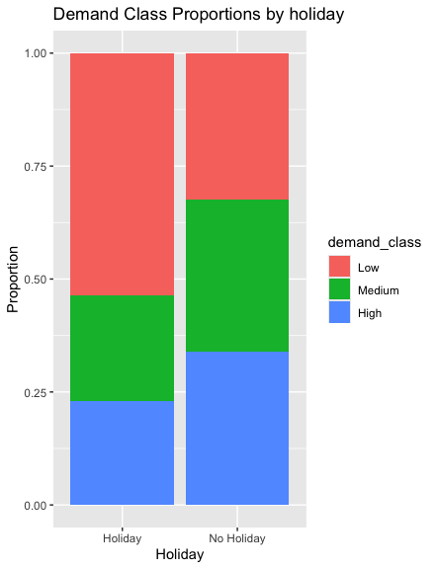

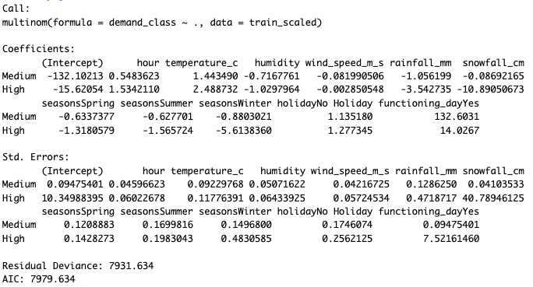
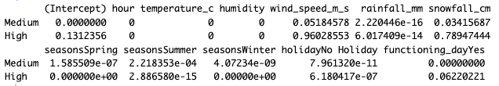

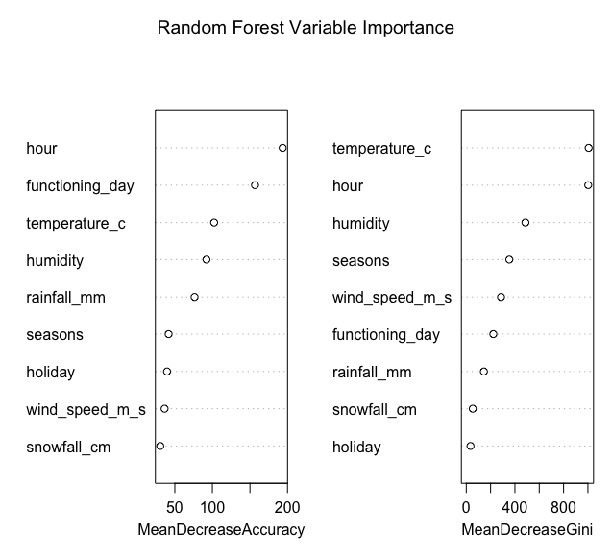
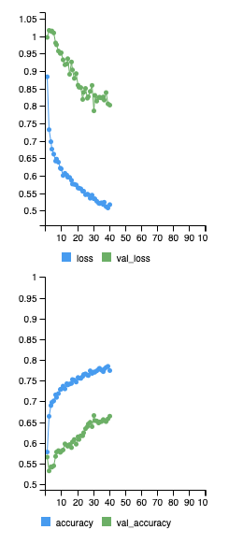
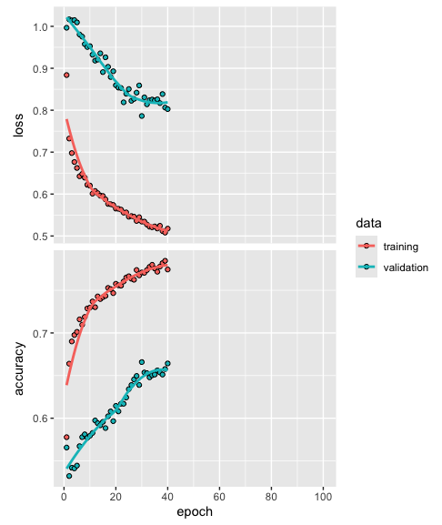

  - Appendix D: Reproducibility

R (version 4.x) was used for all analyses. To guarantee that the results could be repeated, a fixed random seed was employed throughout. The accompanying GitHub repository contains the entire codebase and dataset.

